**Project development phase**

|  |  |
| --- | --- |
| Project Name | importing and securing data in Service Now |
| Team Members | Sarat Chandra Cheekatla, Devaki V, Vallu Mahendra |
| Team ID | LTVIP2025TMID28567 |
| Maximum Marks | 2 Marks |

**Model perfoming testing:**

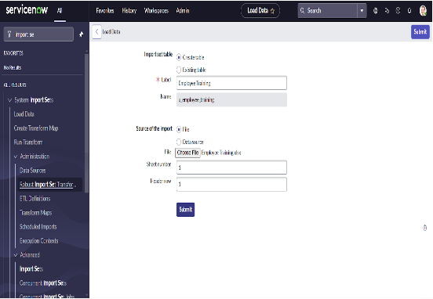**Test:**

**IMPORT DATA :**

**Importing Data:**

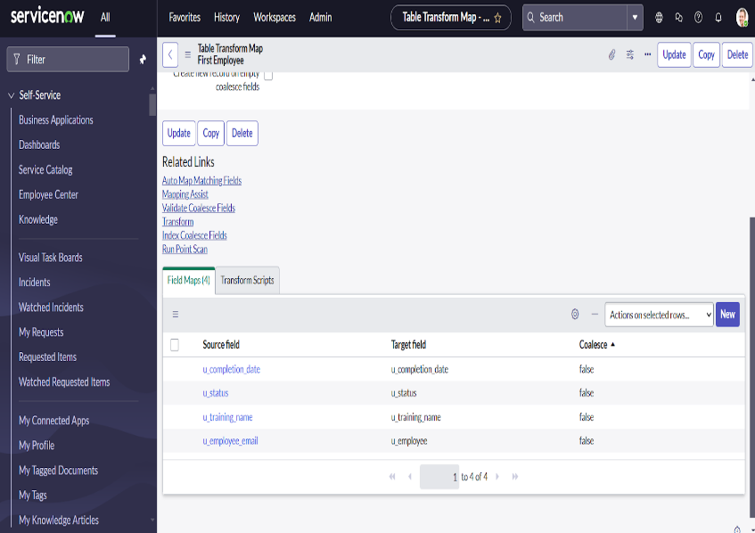

**Map fields:**

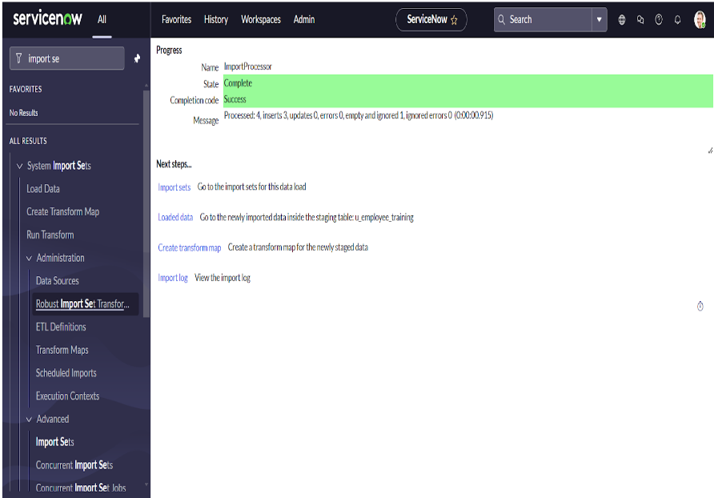

**Dot walking :**

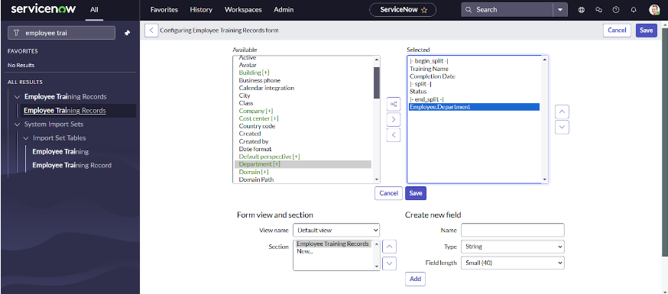



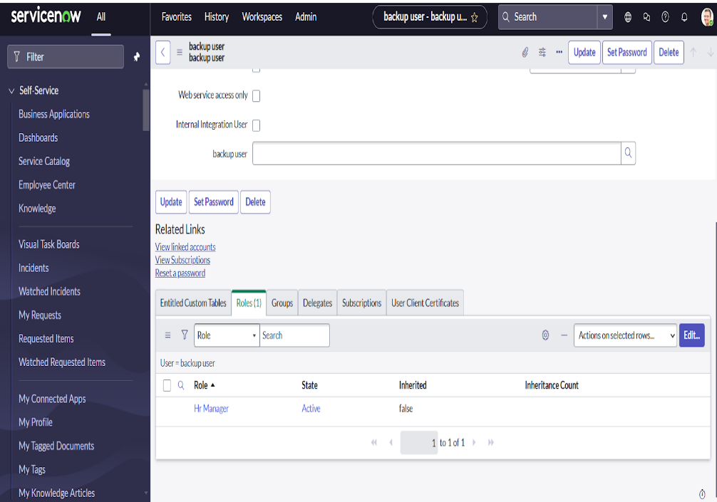

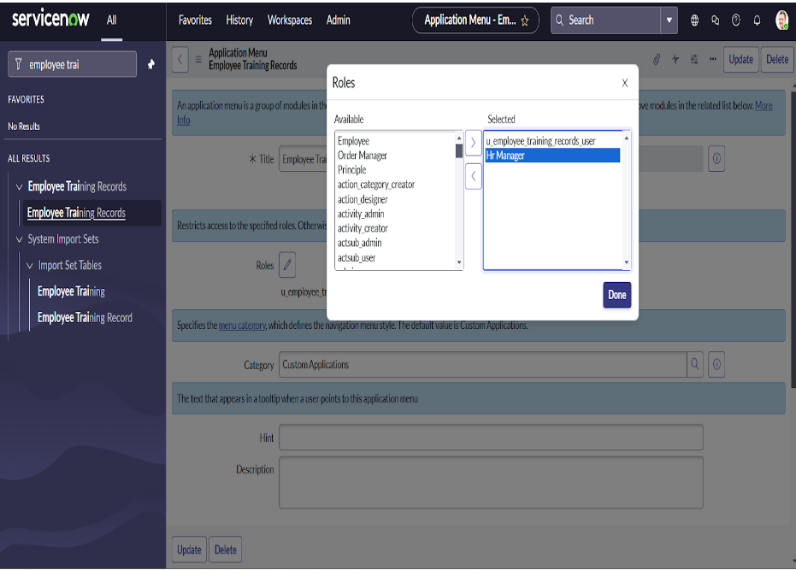**creating a role:**

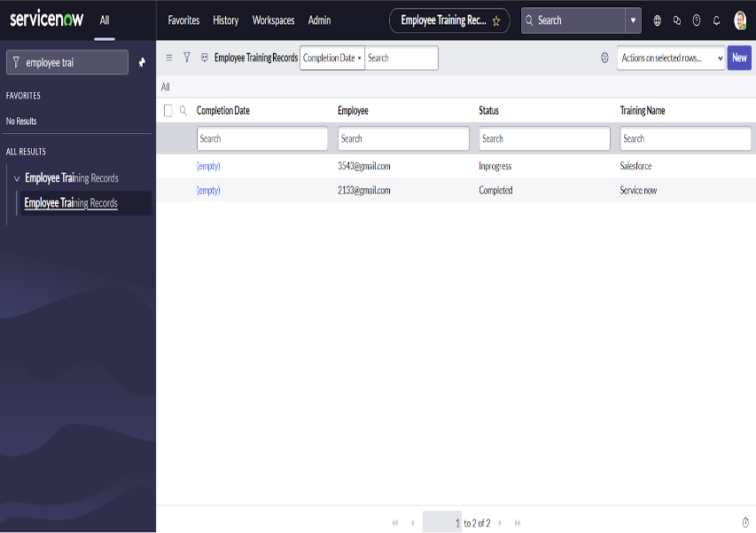

Update to elevate role :

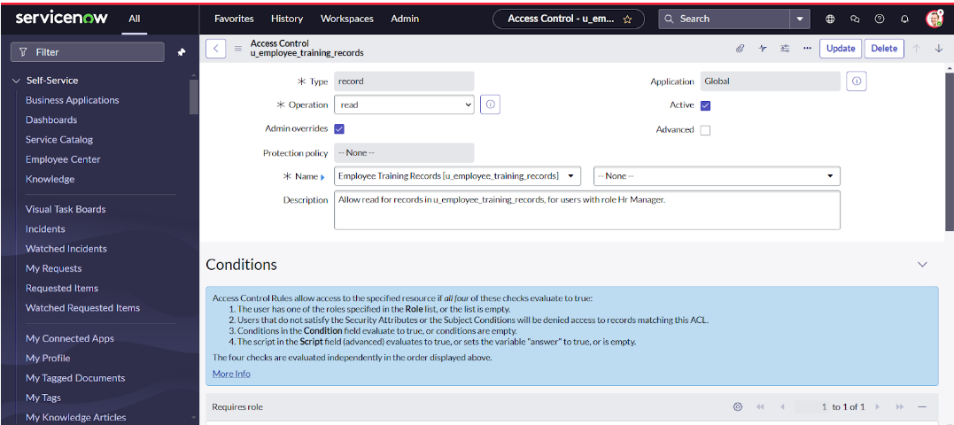 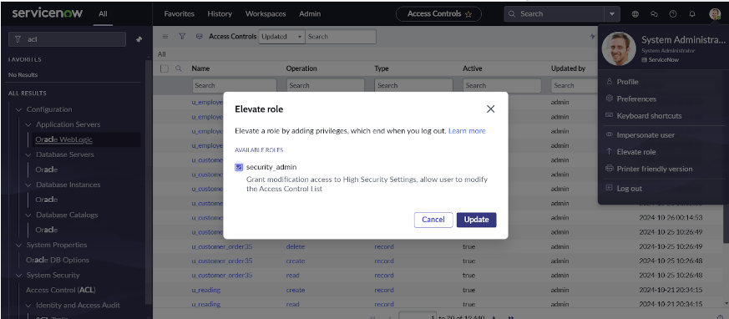

**RESULT:**

**Testing result :**

